Pointillism Painting Assignment
What is Pointillism?
Pointillism is an original form of art created by George Seurat. Pointillism is a bunch of tiny dots formed together to make a picture. When two colours are next to each other, your eye mixes them and that is called optical mixing. Using optical mixing instead of physically mixing intensifies the colour.
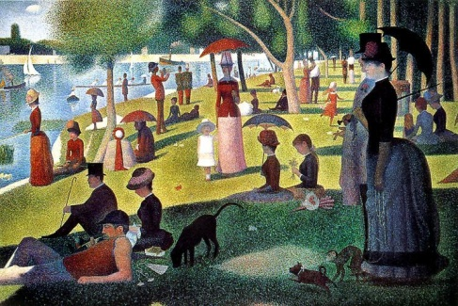
Sunday afternoon on the Island of Grande Jatte by Seurat
Technique:
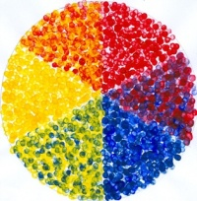
Application of two colours next to each other to create third colour.
Use of sticks, back of brushes as well as paintbrush.
Other examples:
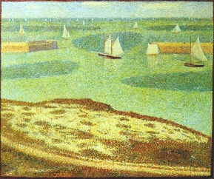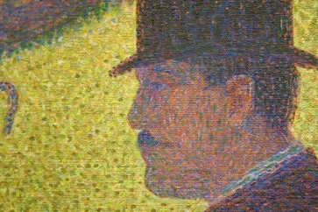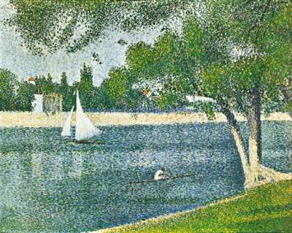
BRIEF:
- Develop a composition using direct observation or a photograph. Using photography is not always suitable but in this assignment it makes a useful reference. Use a sea scape or landscape with trees.
- Develop the composition on the 9 X 5 inch board (prepared with white gesso or undercoat) -use landscape format.
- Using optical mixing create a painting using oil paint and medium.
- Create a colour contrast using complimentary colours.
- Complete for week 4

