Ink Drawing:

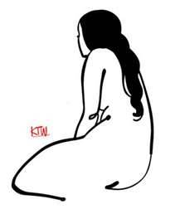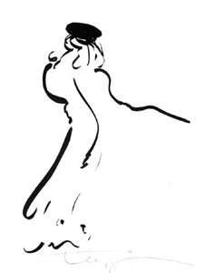

Drawing ink first appeared in China, about 3,000 BCE. This early ink was a combination of pinewood smoke, lamp oil, and gelatin from animal skins. Next, about 400 CE, a new ink formula began to be used, incorporating ferrous sulfate (produced from iron and sulfuric acid), tannin (produced from gall-nuts) and a thickener. Since then, art inks have been made from a diversity of sources, ranging from sooty carbon based materials (bistre) to dyes derived from berries, oak galls, insects, cuttlefish and crustaceans.
Only black and white inks are permanent, as other inks contain soluble dyes rather than pigments and are not lightfast. For monochrome line drawings, most artists prefer black Indian ink, which is both permanent and waterproof. Coloured waterproof inks (also called artists' drawing inks) are available in a range of about 20 colours. Waterproof ink is essential if you wish to use a wash or tint on top of a line drawing, otherwise the linework will run. Being denser, these inks dry to a slightly gloss finish with a precise painterly quality. Non-waterproof coloured inks contain no shellac and are used mainly for washes. They can also be used for line drawings provided no washes are applied.
India Ink is traditionally a carbon black ink mixed with gum and resin, molded into sticks. The name 'India Ink' is thought to be a misnomer which originated in Europe when this ink, actually from China, was imported via the Indies.
The ink in its solid form is familiar to us as Chinese ink sticks used for Sumi-e. The liquid form is sold as Indian Ink, though its French name is 'Encre de Chine', Chinese Ink.
India Ink formulation usually includes a solvent(ethylene glycol) and binder (traditionally shellac) which dries water-resistant and gives a permanent line, unlike the water-soluble traditional form. Winsor and Newton also market a 'Liquid Indian Ink' which seems to have no solvent or added binder, producing a non-waterproof line.

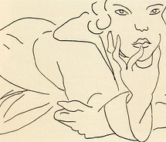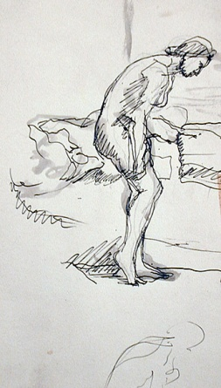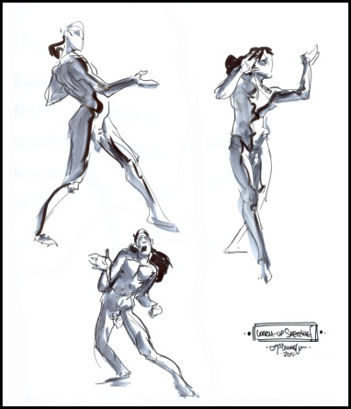

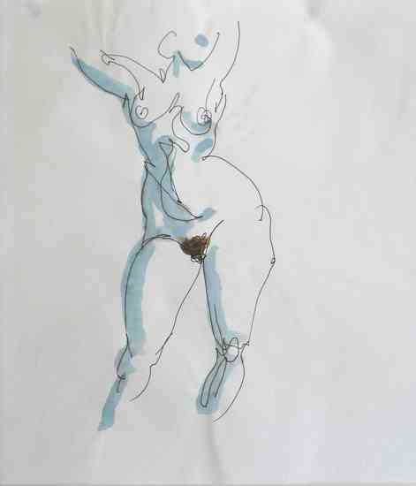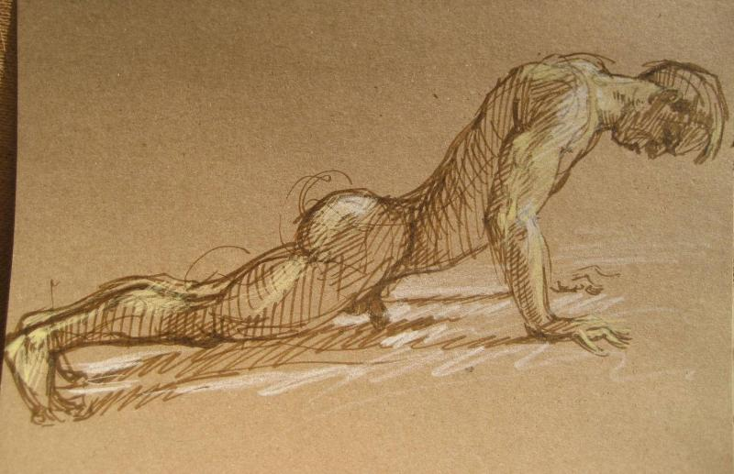

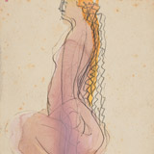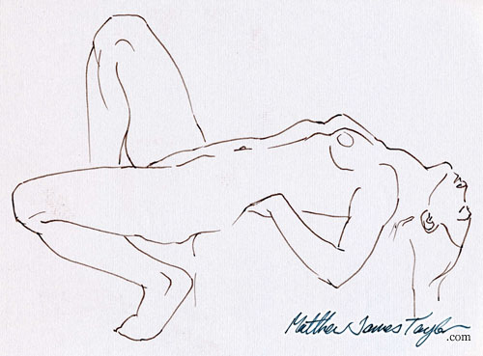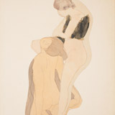

A little history:
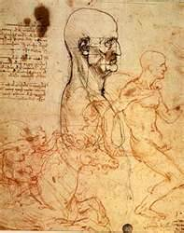
Renaissance Pen and Ink Drawings
During the Renaissance era, stylus, metalpoint and pen with ink were considered as fine line media as opposed to the broad line of charcoal and chalks. The precise effect of pen and ink is exemplified by the virtuoso draughtsman Leonardo Da Vinci in his work Five Grotesque Heads (Royal Library, windsor Castle).
According to the Libro dell'Arte, the practical manual written by the early Renaissance master Cennino Cennini (c.1370-1440), apprentice artists (garzone) progressed to drawing with pen and ink on paper after a year of practising on tablets with stylus, leadpoint or metalpoint. Ink was permanent once applied to paper so errors could not be erased, except by careful scraping.
The most common ink in High Renaissance Italy was made from iron gall. It's principal components, gall nuts, were rich in resin and tannic acid. When soaked in water or wine, strained, and then mixed with iron sulphates and gum arabic, the result was a liquid black ink ideal for drawing. However, over time, iron gall ink fades so that although the ink in most Renaissance drawings is now brown it would originally have been much blacker.
Ink was generally applied to paper with a quill pen. The resulting line could be anything from very thin to very broad. This line spectrum is illustrated by comparing drawings by the brothers Gentile Bellini and Giovanni Bellini. Gentile's Turkish Man (c.1479) and Turkish Woman (c.1480) were drawn with incredibly fine strokes with a thin pen. By contrast, Giovanni's Pieta (c.1480) was executed with broader strokes of a thicker pen. Leonardo Di Vinci's Virgin and Child with a Cat (c.1470s), Madonna with Many Animals by Albrecht Durer (1503) and The Sacrifice of Isaac by Albrecht Altdorfer reveal other effects achievable with pen and ink.
Ink remained popular throughout the Renaissance for a wide variety of drawings from rapid sketches to detailed compositions. Wash and highlighting provided additional effects. However, despite the fluid nature of ink, the need to dip the quill repeatedly made it unsuitable for large scale drawings. These were normally drawn in chalk or charcoal, not ink. For more examples, see: Best Drawings of the Renaissance (c.1400-1550).
Diluted ink could be applied by brush in order to shade an ink drawing. This was often done with the same iron gall ink that was used in pens, but it could also be done with Bistre, a material obtained by soaking wood soot in water. The result was a brown wash that was not viscous enough for use with a pen but ideal for use with a brush. The application of wash to a pen drawing enhanced the three-D effect of the image. Examples include Benozzo Gozzoli's Studies of a Hand, Three Angels and Christ (1447), Filippino Lippi's The Triumph of St Thomas Aquinas (c.1487) and Shallow Vessel (1524-46) by Giulio Romano.
Artists occasionally made brush drawings in ink or bistre without a pen; examples include Head Of A Middle-Aged Man (c.1507) by Vittore Carpaccio and Raphael's Drapery Study For Christ in the Disputa (1508). Pen and ink was also used in combination with other media, an example being St Hubert by Jacopo Bellini, a pen and ink drawing over chalk and leadpoint.
Later History
Pen and ink was used by many draughtsmen during the Baroque, Rococo, Romantic, Neoclassical art movements and throughout the nineteenth century. Examples include: Foetus in Utero (1512), a scientific drawing by Leonardo Da Vinci using pen and ink with red chalk (Royal Library, Windsor Castle); Running Youth with Left Arm Extended (1504) by Michelangelo using pen and brown ink (British Museum); Pastoral Landscape by Claude Lorrain (1644) using pen with brown and grey brown wash; The Prophet Jonah Before the Walls of Ninevah (1654) by Rembrandt, reed pen in bistre with wash (Albertina Museum, Vienna); An Island in the Lagoon by Canaletto (18th century), using pen, brown ink and carbon ink wash (Ashmolean Museum, Oxford); numerous drawings by the Spanish artist Francisco Goya; Samuel Palmer's 1825 series of landscapes; View of Arles (1888) by Vincent Van Gogh, ink with reed pen and wash (Museum of Art, Rhode Island); Reclining Nude by Pablo Picasso (20th century), a pure line pen and ink drawing (Fogg Art Museum, Harvard University); Margaret Hilda Thatcher, Baroness Thatcher of Kesteven by Gerald Scarfe (Tate Modern). Another modern example of the use of pen and ink, can be seen in the National Self-Portrait Collection of Ireland at the University of Limerick. See for example the sumi ink portrait by the Irish artist Fionnuala Ni Chiosain.

How to make a Bamboo Pen
First, find yourself some bamboo. Choose a strong, smooth piece longer than the pen you'll want. Make sure it has a joint, or node, in it.
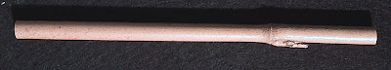
Second, cut the bamboo to size. The node will become the place where your thumb and fingers rest. The length on the other side will become the nib, so make that about 3/4 of an inch or so long. The pen body can be as long or short as you please.
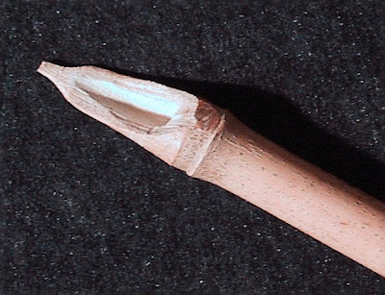
Now, using a Stanley knife, cut the shape in the photo above. First a fairly deep cut near the node, then a longer flat part for the pen nib. Shape the tip into a point.

